September 16, 2025

RE: Planning Department – Brownfields Grant RFQ for Consulting Services

Mayor and Board Members,
The City of Greenfield was awarded $400,000 from USEPA for brownfields work, including assessments, cleanup plans, and the like. The Planning Department is requesting permission to send the attached RFQ out and publish appropriate notice per the grant requirements. A copy of the RFQ has been included with this request for your information.
Thanks,
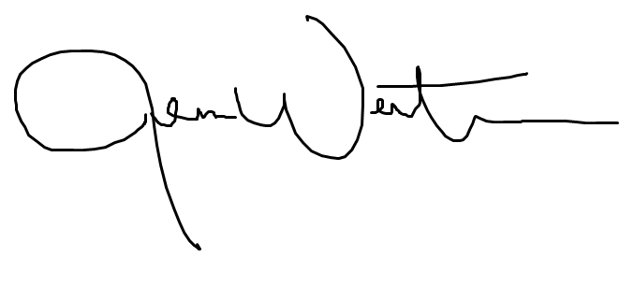
Jenna Wertman, AICP | CPM
Planning Director

