July 30, 2026

Board of Public Works & Safety

RE: Parkrose Sec 2A

Members:

This request relates to plat and bond acceptance for a new section of Parkrose Subdivision. The plat for Section 2A was given secondary approval by the City Plan Commission's Administrative Staff to divide 3.17 acres +/- into 14 lots to be known as Parkrose Section 2A.

Staff recommends acceptance of the Subdivision and Maintenance Agreements, and the Improvement and maintenance surety related to the plat as submitted.

Listed below are the Performance bonds requested to be to be accepted for Section 2A:
Asphalt Surface #272112
Sidewalks and ADA Ramps #272113
Street Trees #272111

Listed Below are the Maintenance Bonds requested to be accepted for Section 2A:
Street Base & Binder #7674516
Sanitary Sewer #7674479
Storm Sewer #7674480
Waterline #7674481
Curbs #7674476
10’ Multi Use Path #7674517

Thank you.

Respectfully,
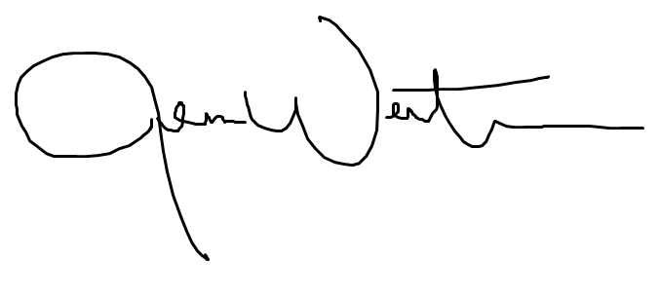

Jenna Wertman, Planning Director

