ORDINANCE NO. 2023/28

AN ORDINANCE AMENDING THE
ZONING CODE OF GREENFIELD, INDIANA

BE IT ORDAINED BY THE COMMON COUNCIL OF THE CITY OF GREENFIELD, INDIANA, UNDER AUTHORITY OF THE INDIANA ADVISORY PLANNING LAW, I.C. §36-7-4, AND ALL ACTS AMENDATORY OR SUPPLEMENTAL THERETO.

SECTION I.

That Section 155.006 ZONE MAP of the Greenfield UDO, Chapter 155 of the CODE OF ORDIANCES OF GREENFIELD, INDIANA, is amended as follows:

The Zone Map referred to in Section 155.006, known as the ZONE MAP, GREENFIELD, INDIANA-2020, as amended, and referred to as the “Official Zone Map” is hereby amended by reclassifying the following described area to the “PUD” Planned Unit Development District:

Legal Description
PART OF THE SOUTHWEST QUARTER OF SECTION 5, TOWNSHIP 15 NORTH, RANGE 7 EAST, SITUATED IN CENTER TOWNSHIP, HANCOCK COUNTY, INDIANA, AND BEING MORE PARTICULARLY DESCRIBED AS FOLLOWS:
COMMENCING AT A BRASS PLUG FOUND AT THE SOUTHWEST CORNER OF SAID SOUTHWEST QUARTER, THENCE ALONG THE SOUTH LINE THEREOF SOUTH 89 DEGREES 34 MINUTES 47 SECONDS EAST 94.75 FEET TO THE SOUTHEAST CORNER OF THE LAND OF THE CITY OF GREENFIELD AS DESCRIBED IN INSTRUMENT NUMBER 201400535 IN THE OFFICE OF THE RECORDER OF HANCOCK COUNTY, INDIANA, AND THE POINT OF BEGINNING; THENCE ON AND ALONG THE PERIMETER OF SAID INSTRUMENT NUMBER 201400535 FOR THE FOLLOWING FIVE (5) COURSES; (1) THENCE NORTH 00 DEGREES 12 MINUTES 26 SECONDS EAST 10.38 FEET; (2) THENCE NORTH 50 DEGREES 07 MINUTES 47 SECONDS WEST 79.86 FEET; (3) THENCE PARALLEL WITH THE WEST LINE OF SAID SOUTHWEST QUARTER NORTH 01 DEGREES 25 MINUTES 39 SECONDS WEST 90.00 FEET; (4) THENCE SOUTH 88 DEGREES 34 MINUTES 21 SECONDS WEST 5.00 FEET; (5) THENCE PARALLEL WITH THE WEST LINE OF SAID SOUTHWEST QUARTER NORTH 01 DEGREES 25 MINUTES 39 SECONDS WEST 1187.45 FEET TO A POINT ON THE NORTH LINE OF THE SOUTHWEST QUARTER OF SAID SOUTHWEST QUARTER; THENCE ON AND ALONG SAID NORTH LINE SOUTH 89 DEGREES 31 MINUTES 41 SECONDS EAST 1073.47 FEET TO A NORTHWESTERLY CORNER OF MCKEE WOODS SECTION 1, RECORDED AS INSTRUMENT NUMBER 201803685 IN SAID RECORDER’S OFFICE; THENCE ON AND ALONG THE PERIMETER OF SAID MCKEE WOODS SECTION 1 FOR THE FOLLOWING THREE (3) COURSES; (1) THENCE CONTINUING SOUTH 89 DEGREES 31 MINUTES 41 SECONDS EAST 200.00 FEET; (2) THENCE NORTH 01 DEGREES 05 MINUTES 30 SECONDS WEST 79.76 FEET; (3) THENCE SOUTH 89 DEGREES 34 MINUTES 44 SECONDS EAST 432.10 FEET TO THE NORTHEAST CORNER OF SAID MCKEE WOODS SECTION 1; THENCE CONTINUING SOUTH 89 DEGREES 34 MINUTES 44 SECONDS EAST 578.49 FEET TO THE NORTHWEST CORNER OF THE LAND OF MATTHEW & KIMBERLY McKEE AS DESCRIBED IN INSTRUMENT NUMBER 9914176 IN SAID RECORDER’S OFFICE; THENCE ALONG THE EAST LINE THEREOF SOUTH 00 DEGREES 25 MINUTES 13 SECONDS WEST 345.10 FEET TO A POINT ON THE NORTH LINE OF WHITCOMB MEADOWS SECTION 4 AS DESCRIBED IN INSTRUMENT NUMBER 9410999 IN SAID RECORDER’S OFFICE; THENCE ALONG SAID NORTH LINE AND ITS WESTERLY EXTENSION NORTH 89 DEGREES 34 MINUTES 47 SECONDS WEST 371.74 FEET; THENCE SOUTH 01 DEGREE 21 MINUTES 52 SECONDS EAST 1071.74 FEET TO A POINT ON THE SOUTH LINE OF SAID SECTION 5; THENCE ON AND ALONG SAID SOUTH LINE NORTH 89 DEGREES 34 MINUTES 47 SECONDS WEST 1835.71 FEET TO THE POINT OF BEGINNING, CONTAINING 62.42 ACRES, MORE OR LESS.

The above-described real estate shall be developed in accordance with the terms, conditions and statements of the Parkrose Planned Unit Development Statement attached hereto as Exhibit 1, and by reference the Planned Unit Development Statement are incorporated herein.

Parkrose Planned Unit Development Statement

Development Standards

SECTION I. STATEMENT OF PURPOSE AND INTENT:

A. Parkrose is a planned single-family detached and attached (duplex) community. The primary goal is to provide a single-family detached and attached (duplex-paired patio) community with passive and active open space features, including seating areas at the main pond and an extensive walking trail network. The proposed development standards are intended to carry out the design goals of this planned community. They are written to ensure a unified, quality development and continuity in design.

B. The following principles will be used in guiding development of a planned community that can respond to changing market conditions. The Parkrose PUD shall:

- Achieve flexibility and variety of housing types, including detached single-family and fee-simple paired patio homes, which will produce a variety of housing choices;

- Connect two existing unconnected segments of Center Street;

- Replat the existing McKee residences to eliminate existing plat irregularities;

- Encourage a more creative approach in land and building site planning;

- Encourage an efficient, aesthetic, and desirable use of open space and/or common area; and

- Promote variety in the physical development pattern of the community.
SECTION II. AUTHORITY

These standards shall apply to all property contained within Parkrose as described herein. These regulations and requirements shall become part of the Planned Unit Development Ordinance and shall provide the governing standards for review, approval, and modification of all land use and development activities occurring at Parkrose. Provisions of these Standards shall prevail and govern the development of Parkrose superseding the existing zoning ordinance. The zoning ordinances and regulations of the RM – Residential Moderate Density District of the Unified Development Ordinance shall apply if the provisions of these Standards do not address a specific subject.

SECTION III. SITE LOCATION

Parkrose is a proposed residential development of approximately sixty-two and forty-two hundredths (62.42) acres located at the northeast corner of Davis Road and Franklin Street.

(remainder of page intentionally left blank)

SECTION IV. LAND USE

TABLE 1. Development Summary

Acreage | 62.42 acres
Number of Units | 182 lots  (116 Single-Family, 64 Paired, 2 Parent Tract Replat)
Density | 3.44 units per acre without McKee Parent Tract Replat  2.92 units per acre including McKee Parent Tract Replat  3.15 units per acre- Single-Family  4.12 units per acre- Paired
Underlying Zoning | RM- Residential Moderate Density District

- Land Use Categories

TABLE 2. LAND USE CATEGORIES

Use | Number  of Lots | Land Area | Building Designations on Plat
Residential – Single-Family  Maple Street Lot (“MSH”) | 60 | 36.84 acres | Maple Street Lot
Residential – Single-Family  Designer Lot  (“Designer”) | 56 |  | Designer Lot
Residential – Paired Patio Lot  (“Paired”) | 64 | 15.55 acres | Duplex Lot
McKee Parent Tract re-plat | 2 | 10.03 acres | Existing Homesites

GENERAL DESCRIPTION
The proposed Development, named Parkrose, is a single-family and duplex subdivision consisting of up to one-hundred eighty-two (182) homesites to be developed over four (4) phases.

Parkrose features a mix of passive and active open spaces, including a network of paths, landscaped berms, and a gazebo/trellis with seating areas by the pond. Reduced lot widths for Paired Patio Units result in additional open space than would otherwise occur if wider lots were developed. The layout of the site contributes to a more aesthetically pleasing community with a park-like environment. Lots backing to open spaces increase home values (i.e., tax base) as they are more desirable to the vast majority of buyers. As part of the development, Center Street will be extended, eliminating the disconnected street stubs and creating better connectivity for residents. Additionally, Parkrose will replat the existing residences on the Parent Tract, creating frontage for one residence on an internal street and one on Center Street.

Housing Types
The applicant is proposing the Paired Patio Home Collection, the Maple Street Home Collection, and the Designer Home Collection. The Paired Patio Home Collection targets buyers seeking low maintenance living. The mandatory homeowners’ association provides mowing, snow plowing/pushing services for driveways and sidewalks, and front yard landscaping maintenance for the Paired Patio Home Collection. The inclusion of these services makes the Paired Patio Home Collection ideal for retirees and busy young professionals.

The Maple Street Home Collection targets first-time homebuyers with young families. The Designer Home Collection represents the intersection of high-quality design and affordability that appeals to a wide range of budgets and tastes, targeting a move-up or an affluent first-time homebuyer. All products within Parkrose are served by a mandatory homeowner’s association.

(remainder of page intentionally left blank)

TABLE 3. RESIDENTIAL DEVELOPMENT STANDARDS

Item | Requirement
Minimum Front Building Setback | 25’
Minimum Perimeter Setback | 40’ along Franklin Street and Davis Road
Minimum Distance between Buildings | 12’- Single Family (MSH and Designer)  12’- per combined Paired lots XX-a and XX-b- Paired
Minimum Side Yard Setback | 5’- Single Family (MSH and Designer)  5’- per combined Paired lots XX-a and XX-b- Paired
Minimum Rear Yard Setback | 20’
Minimum Rear Yard Clearance from Back of Primary Building to an Easement | 20’
Maximum Building Height | 35’
Minimum Lot Width | 60’ – Single Family (MSH and Designer)  68’ - per combined Paired lots XX-a and XX-b- Paired
Minimum Lot Area | 7,000 square feet - Single Family (MSH and Designer)  3,500 per lot/7,000 square feet- per combined Paired lots XX-a and XX-b- Paired
Garages and Driveways | Each house shall have an attached garage that accommodates no fewer than two (2) cars. All homes shall have a minimum of four (4) parking spaces on each lot, which includes two (2) enclosed by the garage and two (2) spaces in front of the garage, located between the garage and the street.  An example of the paired driveway configuration is attached as Exhibit D.  Paired units shall not be restricted to thirty percent (30%) of the lineal footage defined in Section 155.068. Single Family cul-de-sac lots shall be restricted to fifty percent (50%) of the lineal footage, instead of thirty (30%) defined in Section 155.068.
Streets and sidewalks | Center Street will voluntarily be extended. Sidewalks on Center Street will match existing four (4) feet wide sidewalks. All other sidewalks will be five (5) feet wide. Multiuse internal paths will be eight (8) feet wide and perimeter paths will be ten (10) feet wide, as indicated on Exhibit A. Over five-thousand (5,000) linear feet of pathways are proposed for Parkrose. Paths not within the right-of-way will be maintained by the HOA. Petitioner will cooperate with City to connect a sidewalk to Center Street along Davis Road in order to enhance pedestrian connectivity.
Exterior Colors | Bold and neutral color palettes shall be permitted on home exteriors. A mixed palette on a single building should be carefully selected so that all colors are harmonious with each other. Sample color packages are attached as Exhibit E.
Exterior Materials | Exterior cladding: Permitted materials shall include the following:  - Brick veneer  - Stone/cultured stone or stone veneer  - Wood lap siding, composite siding and cedar shake siding (painted or stained)  - Stucco- per industry standards- light to medium textures  - Fiber cement lap or panel  - Vinyl siding (minimum 0.44mm)
Entry Monumentation | An entry monument will be located on West Davis Road.  Maximum sign area - thirty-two (32) square feet.  Maximum signs per frontage- one (1) sign per frontage.  Maximum sign height- Monument: Eight (8) feet in sign height on a thirty-six (36) inch or shorter base.  An example sign is included as an Exhibit B to this document.

(remainder of page intentionally left blank)

TABLE 4. Architectural STANDARDS

All Standards in Section 155.101 of the Zoning Ordinance; DESIGN STANDARDS FOR SINGLE-UNIT/ MULTI-UNIT DWELLINGS shall be met with the following exceptions; however, Fischer Homes reserves the right to file for modifications with Planning Commission from Design Standards, per Section 155.105:

Ordinance Standard to be Modified | Maple Street Homes (“MSH”) | Paired Patio Homes  (“Paired”)
§155.101 2(B) - Home Mix Guidelines | MSH homes shall meet this standard.  (Intentionally left blank) | No duplication of the same elevation within one (1) building on the same side of the street.  No duplication of the same color package within one (1) building on the same side of the street or lot directly across the street.
 |  | Rationale: The loft option for the Wembley is often selected, which provides diversity in the streetscape.
§155.101 2(D) – Minimum of one (1) window per story | MSH homes shall meet this standard.  (Intentionally left blank) | In total, three (3) seven (7) square foot windows per side elevation.
 |  | Rationale: The intent of the code is met; three windows offer additional detail to the side of the building.
§155.101 3(A) – Roof pitch | Exterior designs will meet the requirement for 5:12 roof pitch with at least one reverse gable. | Minimum 5:12 roof pitch when two (2) reverse gables on units with lofts.  Minimum 4:12 roof pitch on units without lofts.
 | Rationale: Fischer Homes will provide a variety of roof pitches and architecture for a more interesting streetscape. | Rationale: Fischer Homes will provide an enhanced streetscape with a variation of roof pitches. We will include 2 reverse gables in lieu of the one required. This combination will diminish the visual impact of the front main roof as well as enhance the exterior. Consumers in the Greater Indianapolis market show a strong preference for units with lofts.
§155.101 3(B) – Minimum nine (9) inch overhangs. Minimum eight (8) inch overhangs at brick wall. | Porches only to have minimum eight (8) inch overhang. All other parts of the building shall comply. | Porches only have minimum six (6) inch overhang. All other parts of building shall comply.
 | Rationale: This request is only for porches; the rest of the home will be compliant.
§155.101 5(A) – Garage Façade and Projection | MSH homes shall meet this standard.  (Intentionally left blank) | On up to 75% of Paired buildings, garage door openings may be up to 58% of the width of the front façade.
 |  | Garage projects twenty-two feet, three and one-half inches (22’ 3 ½”) from the front façade and seventeen feet nine and one half inch (17’ 9 ½“) from the front porch of the building.
 |  | Rationale: Fischer Homes requests approval of our designs as presented in the attachment. Our designs offer multiple styles and a number of front veneer choices.
§155.101 5(E) – Garages | MSH homes shall meet this standard.  (Intentionally left blank) | 75% of Paired products to be front-entry. A minimum of 25% of Paired buildings to have courtyard drives. Specific locations to be determined at the time of construction.
 |  | Rationale: Fischer Homes’ designs offer a variety of styles. A z-lot courtyard configuration can be utilized to allow for a courtyard drive on one half of some buildings to meet the intent of this section. See Exhibits C and D.

All Standards in Section 155.101 of the Zoning Ordinance; DESIGN STANDARDS FOR SINGLE-UNIT/ MULTI-UNIT DWELLINGS shall be met for Designer Homes; however, Fischer Homes reserves the right to file for modifications with Planning Commission from Design Standards, per Section 155.105.
EXHIBIT A- Pathway and Amenity Plan
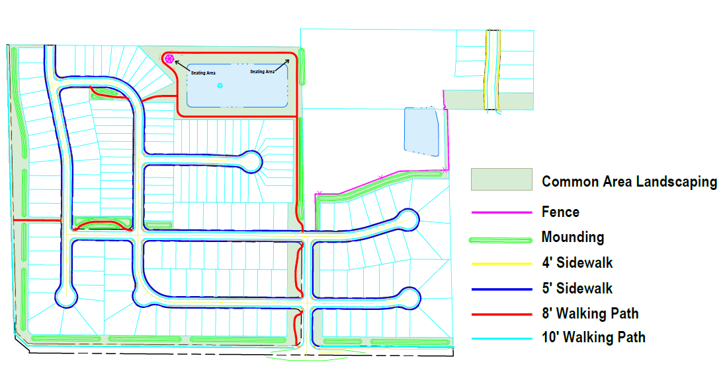

EXHIBIT B- Entry Monument

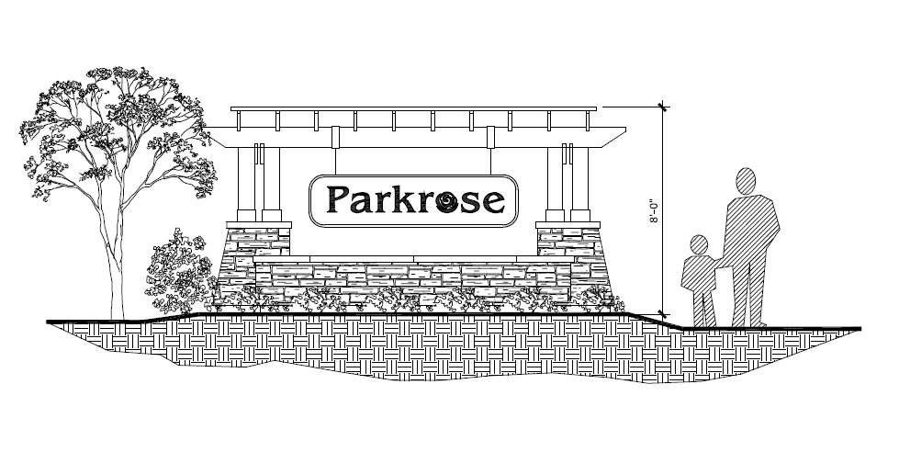

EXHIBIT C- Example Product Renderings
The provided renderings are sample representations of each product only. Supplemental sets of architectural renderings shall be provided to and maintained by Greenfield Planning staff.

Designer

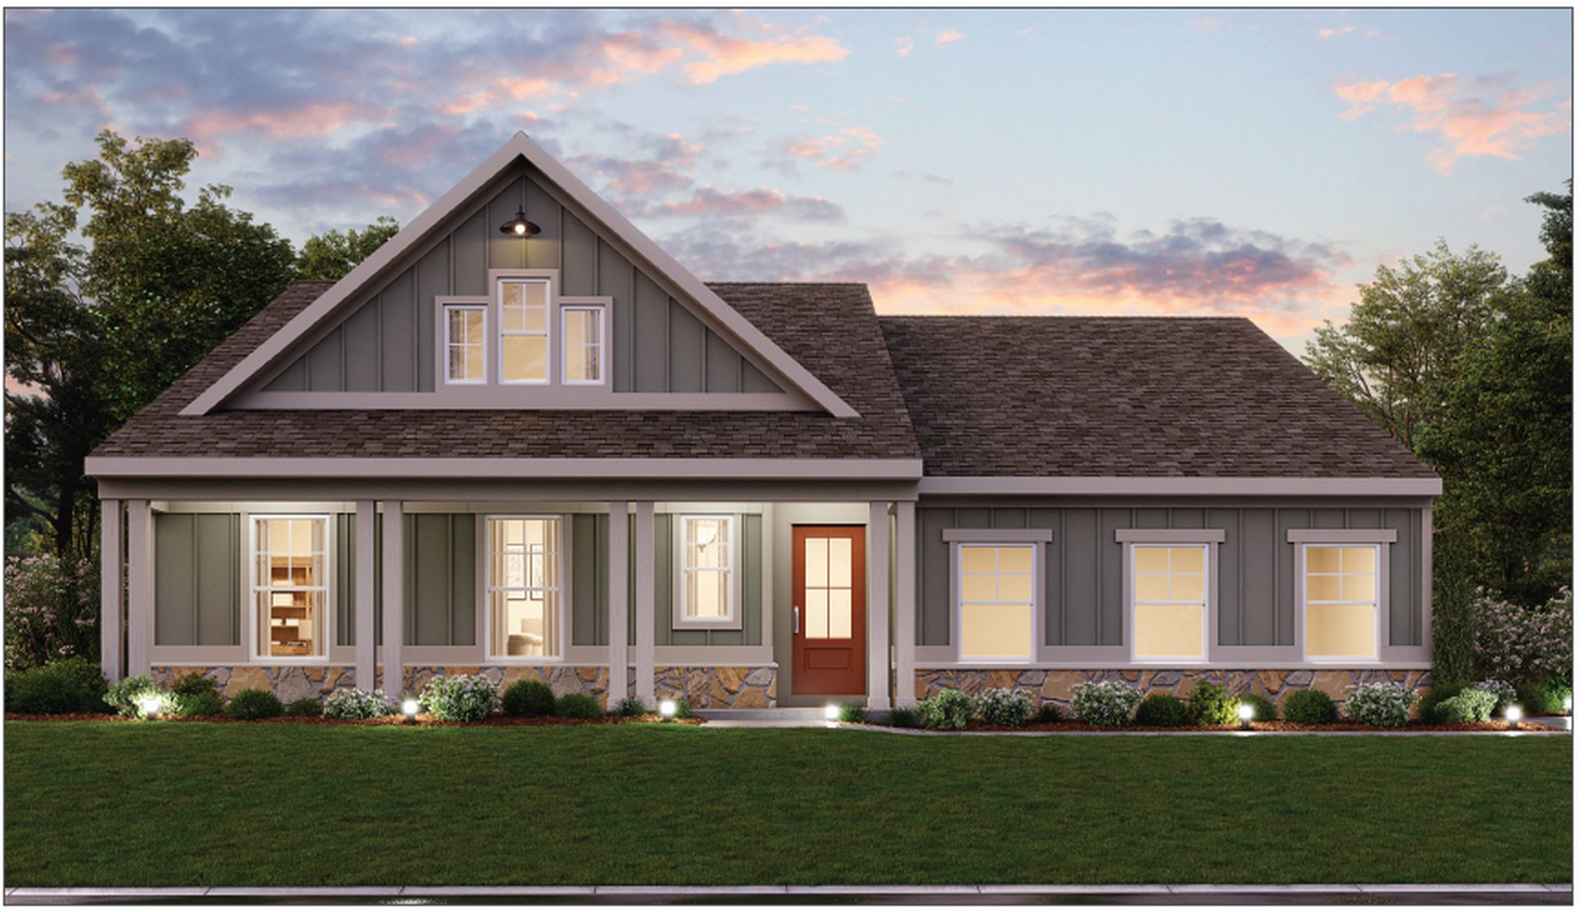
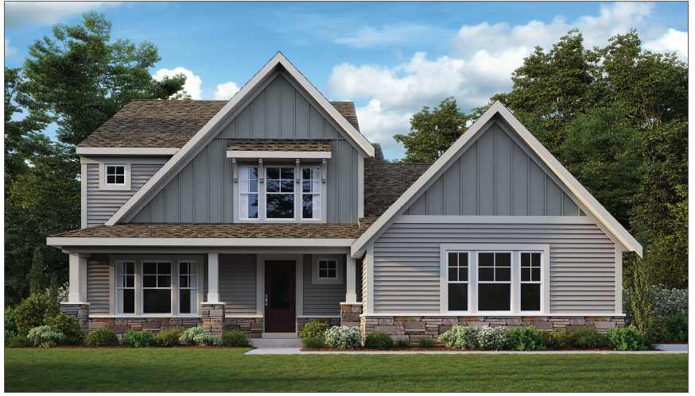

Maple Street

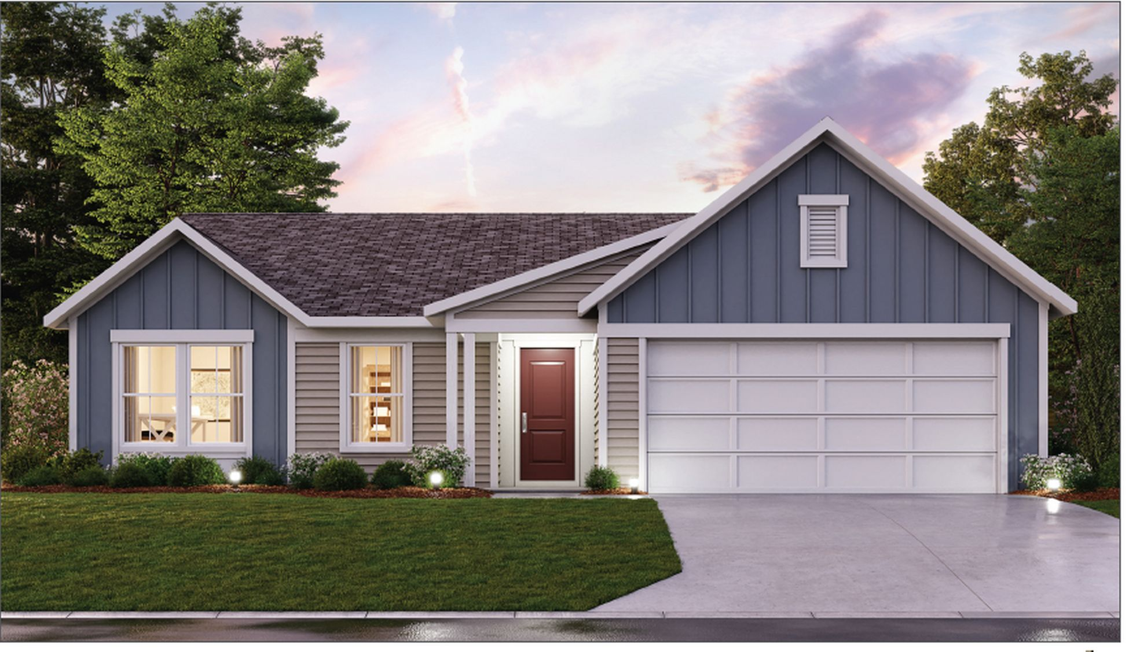
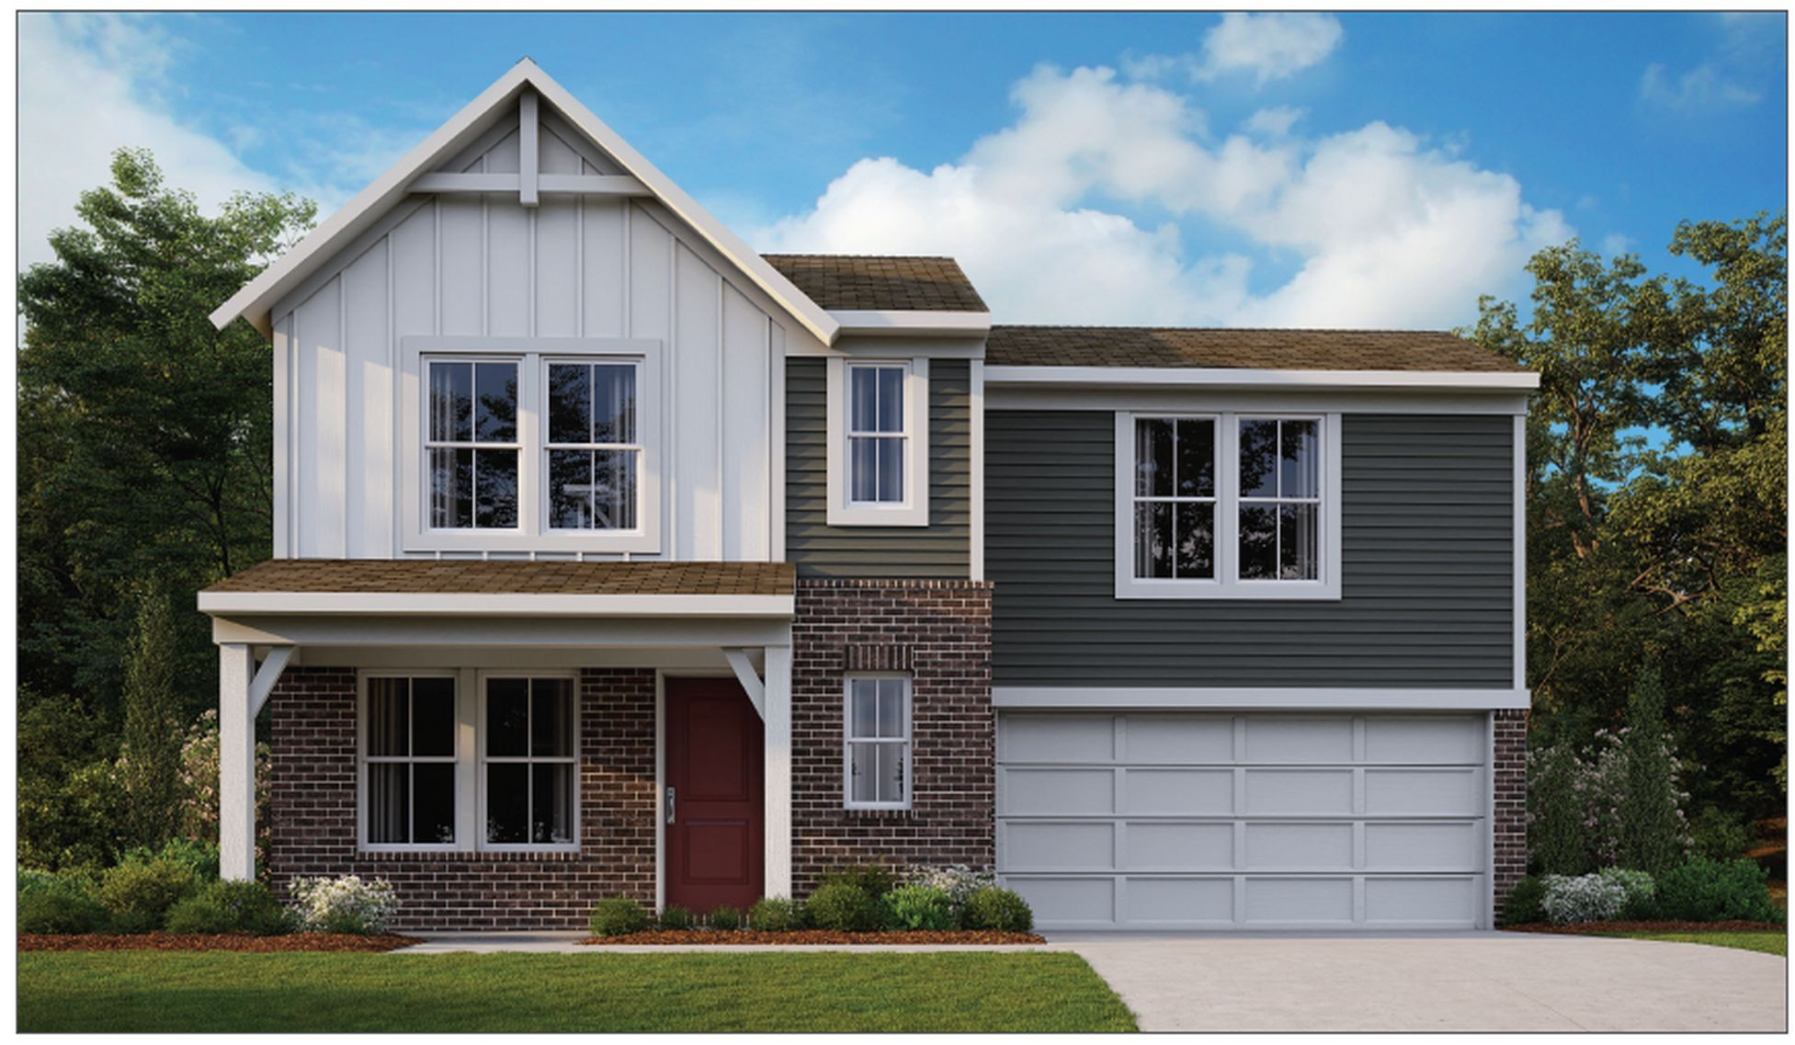
Paired Patio

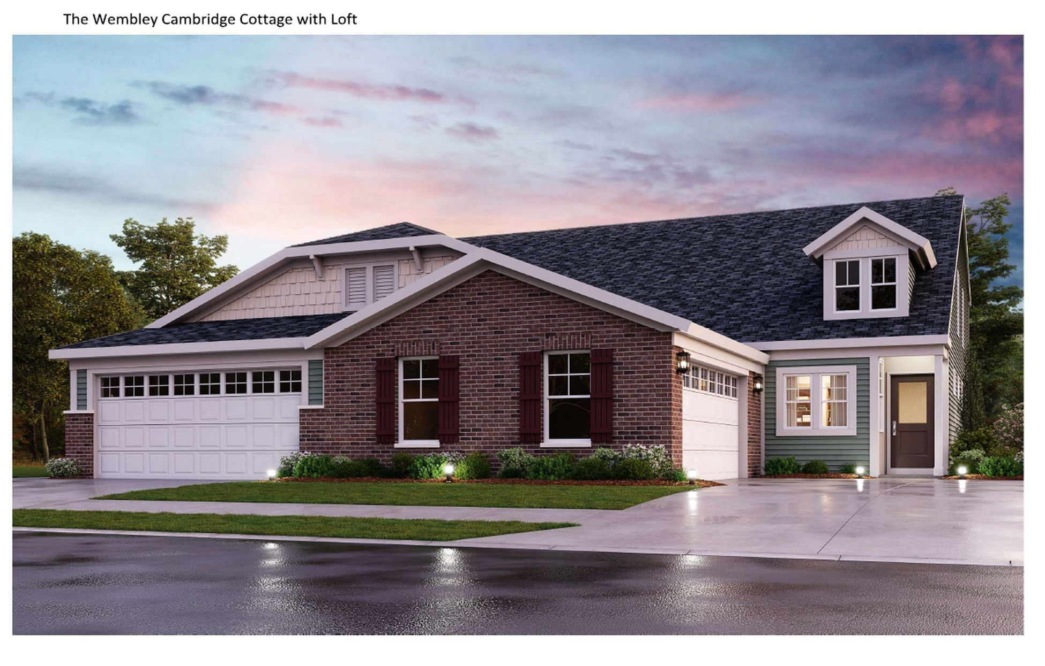

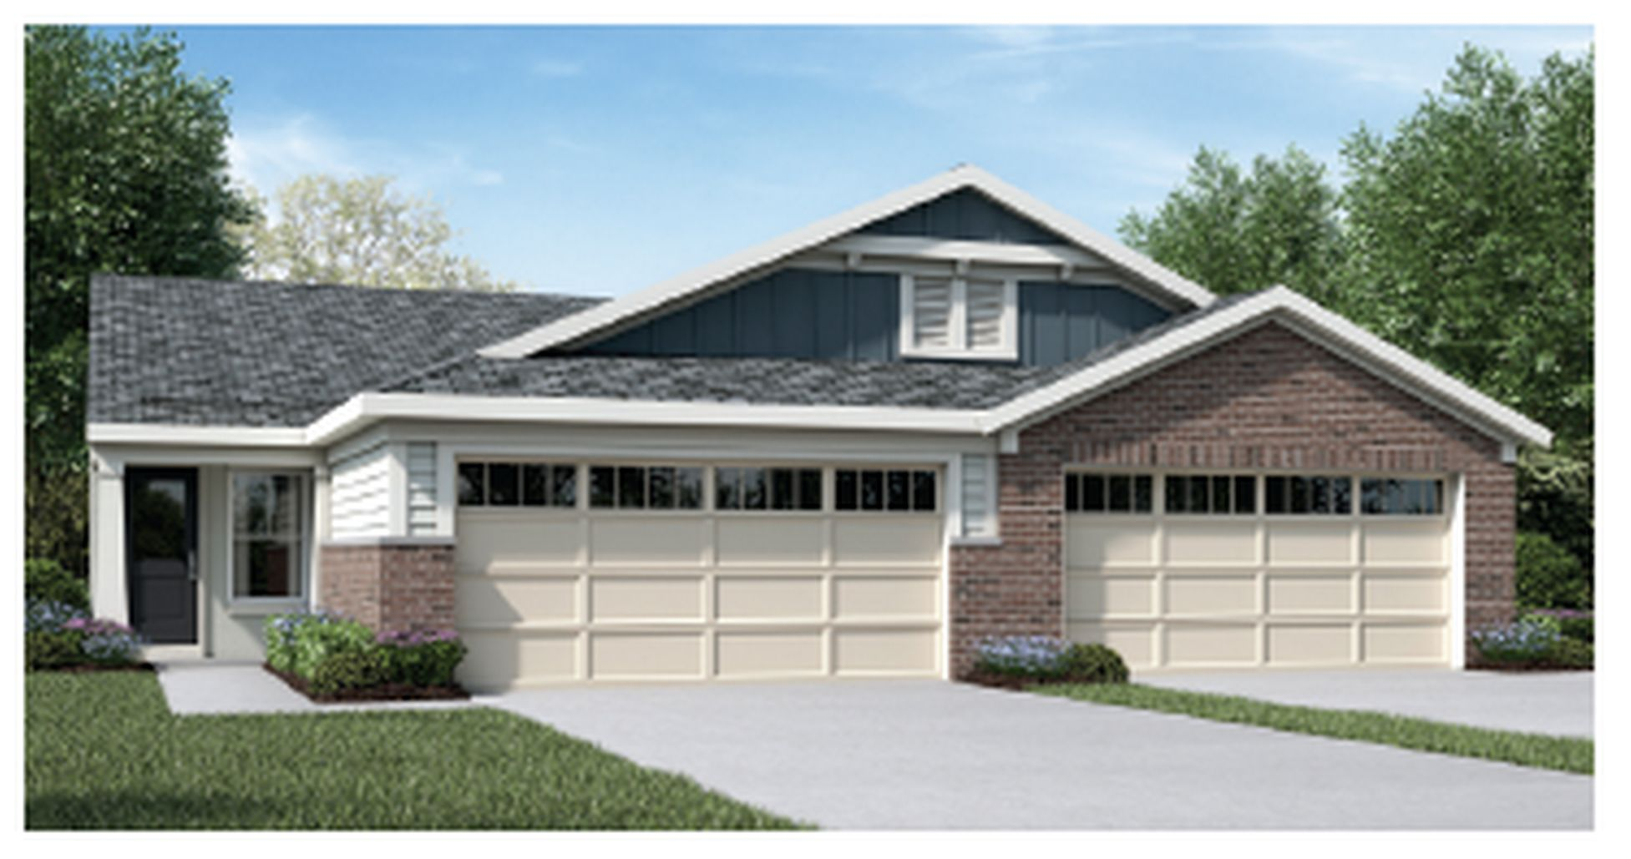

Exhibit D- Typical Paired Cul-de-sac Driveway Configuration
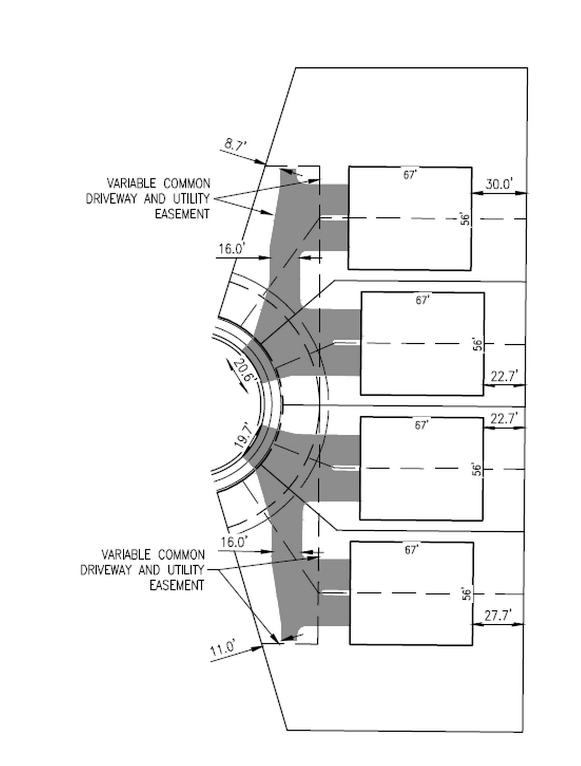

Exhibit E- Example Color Palettes

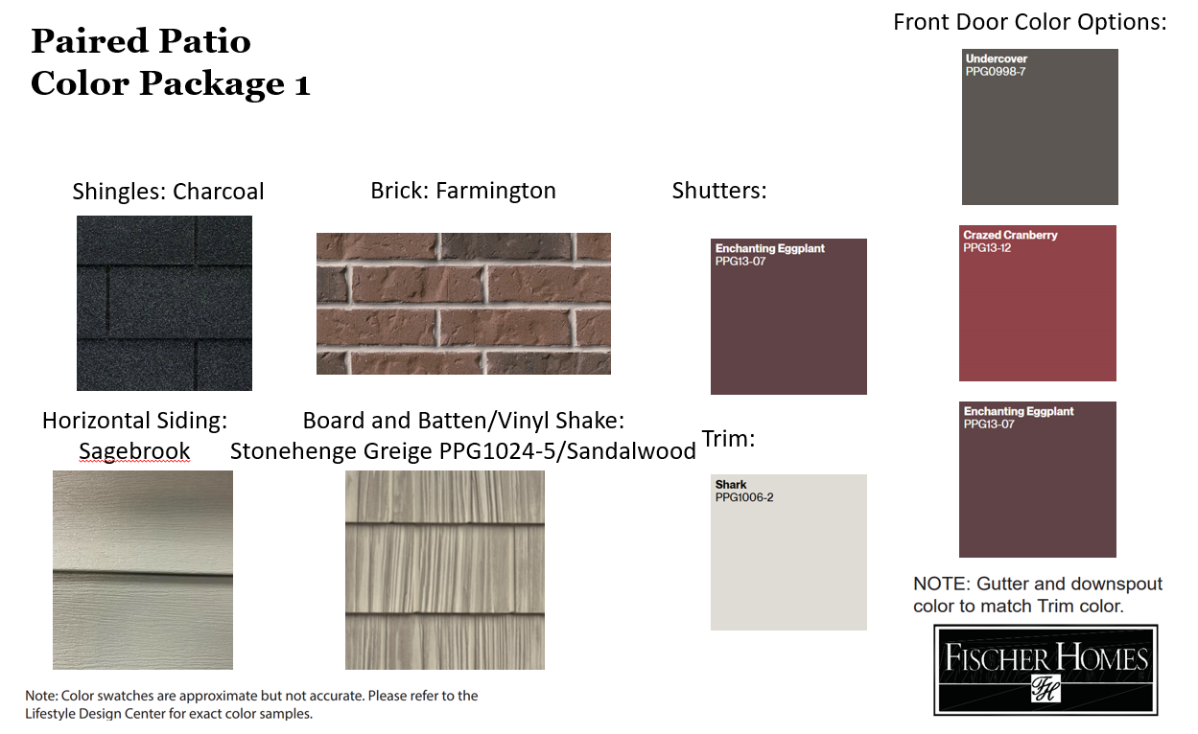

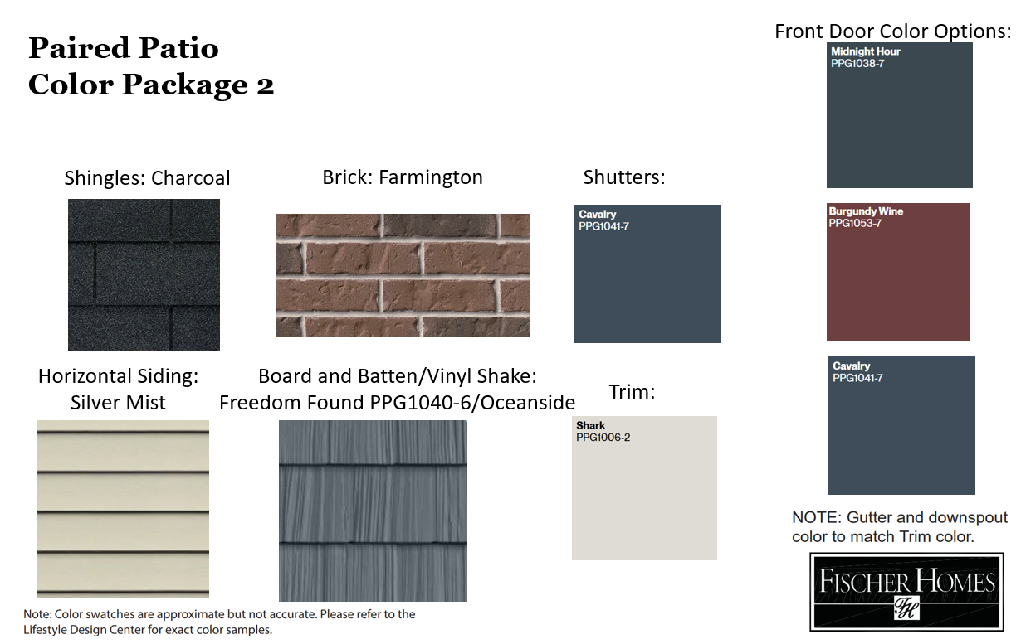

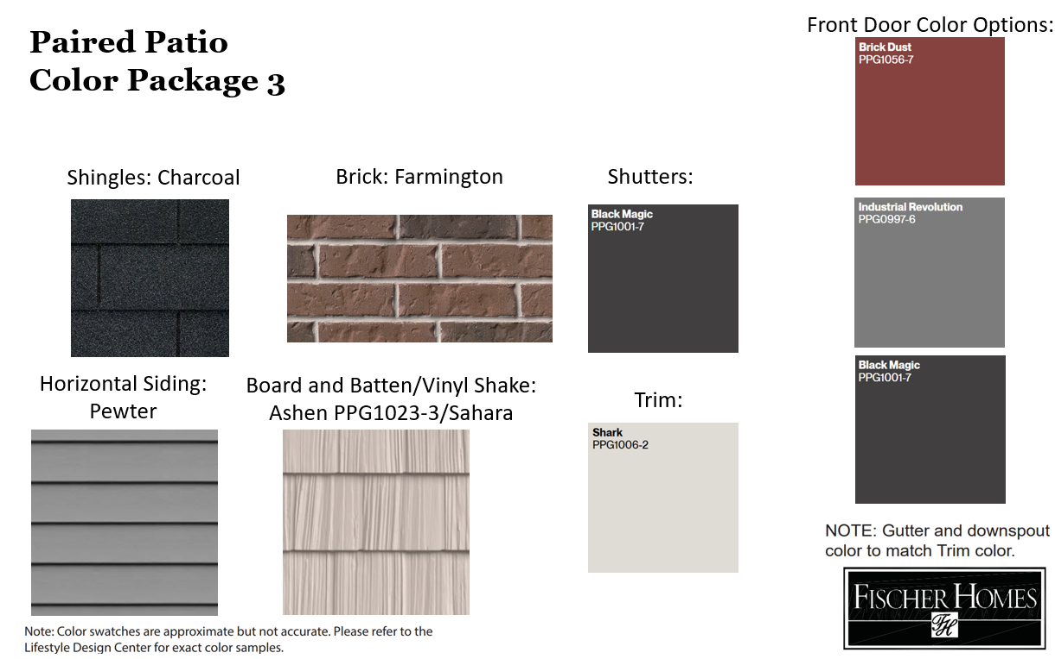

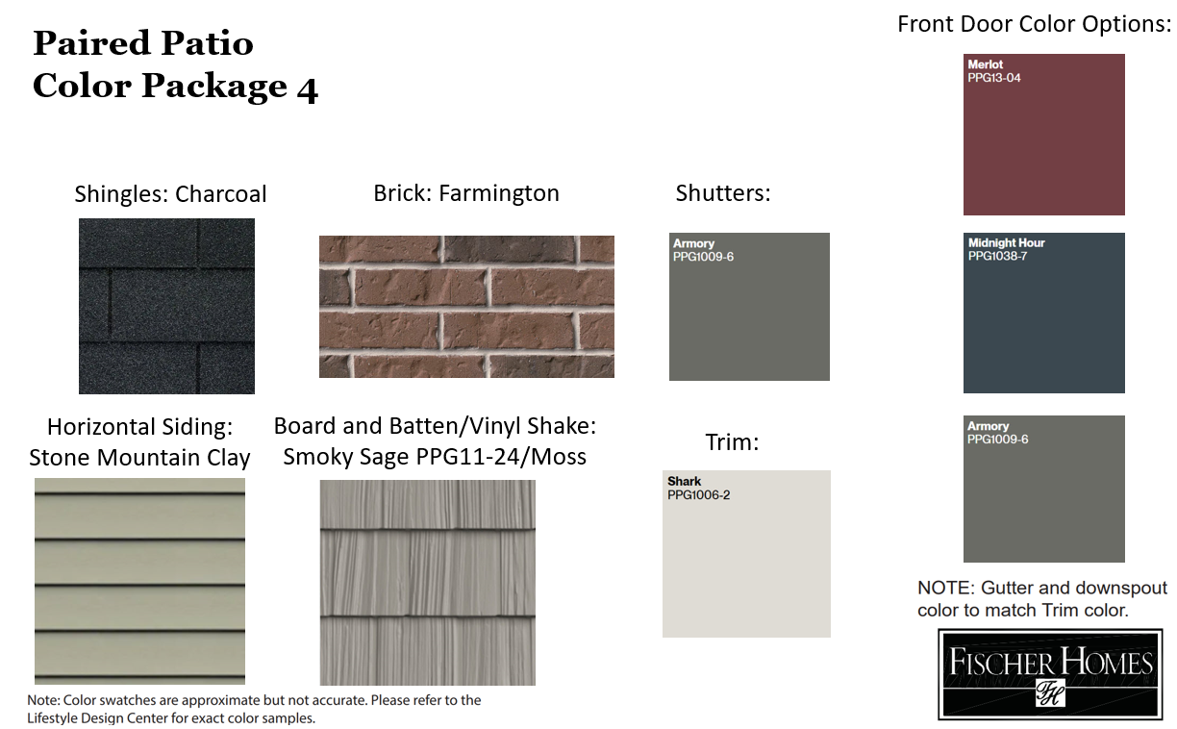
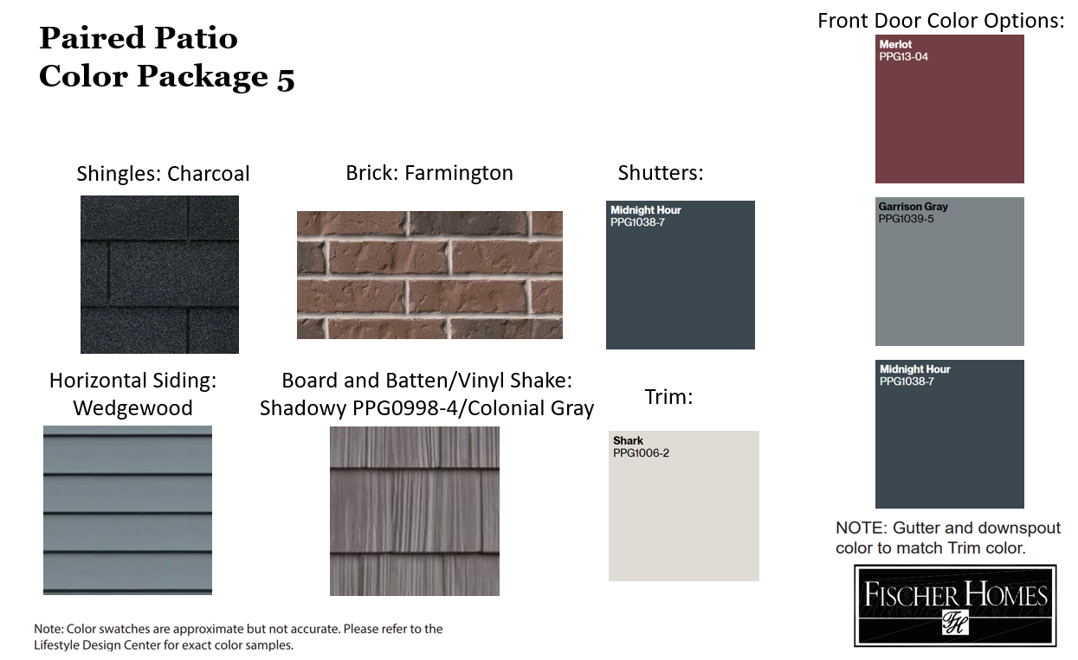

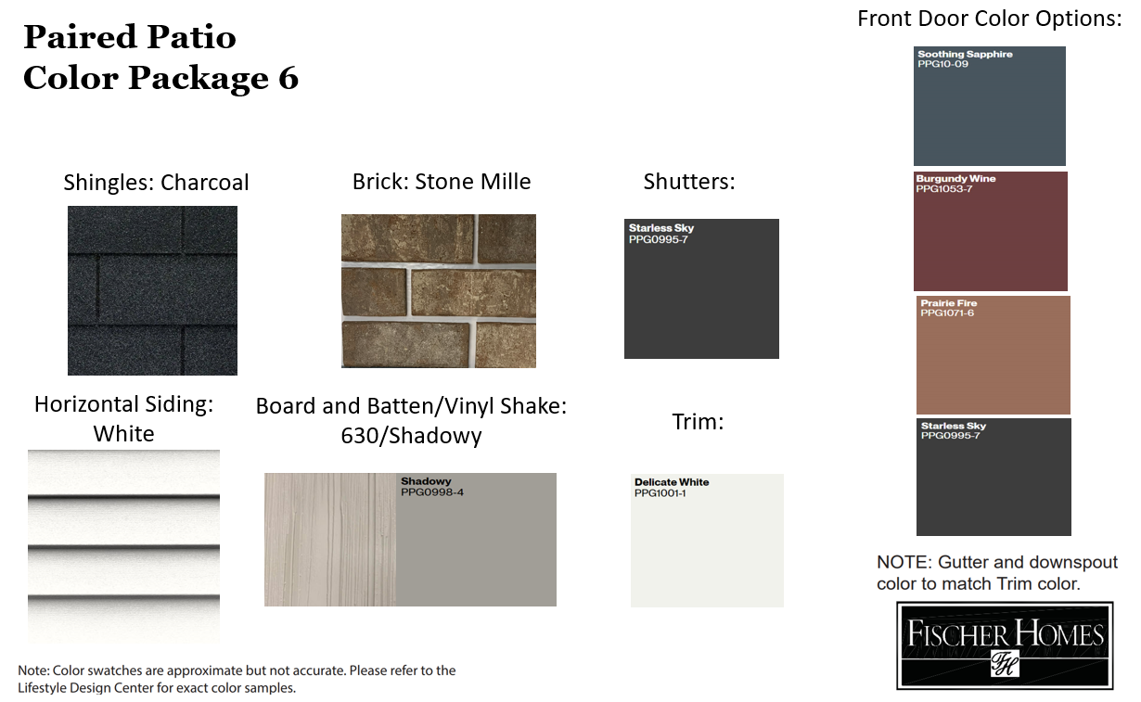

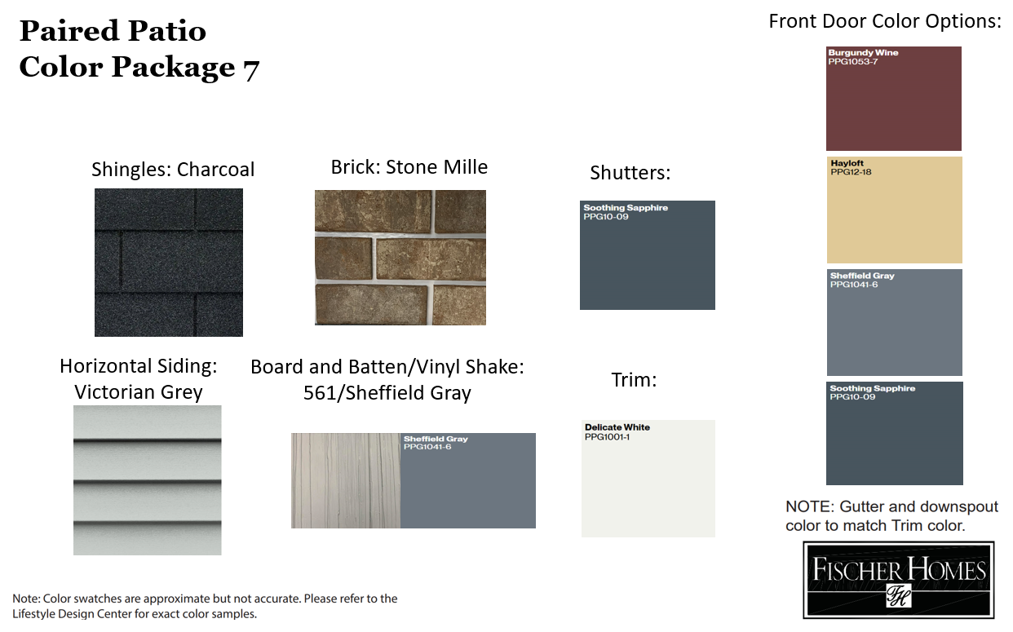

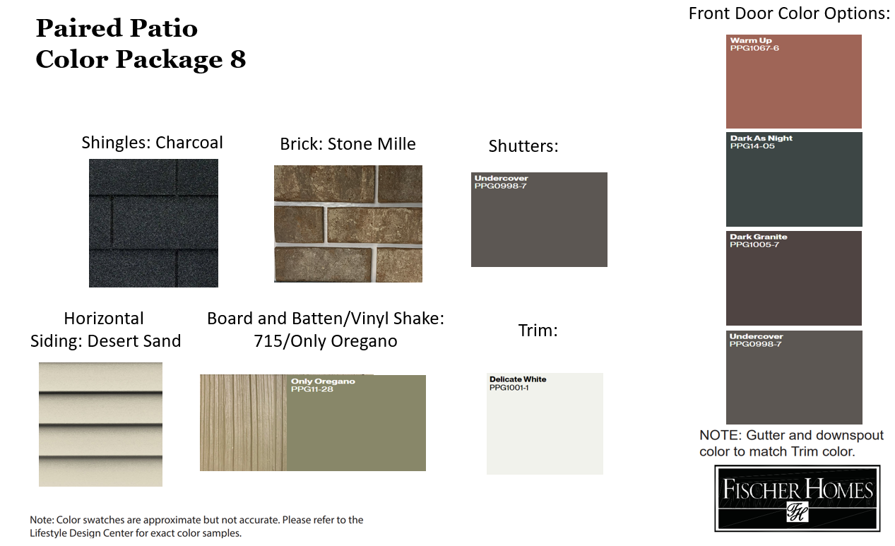

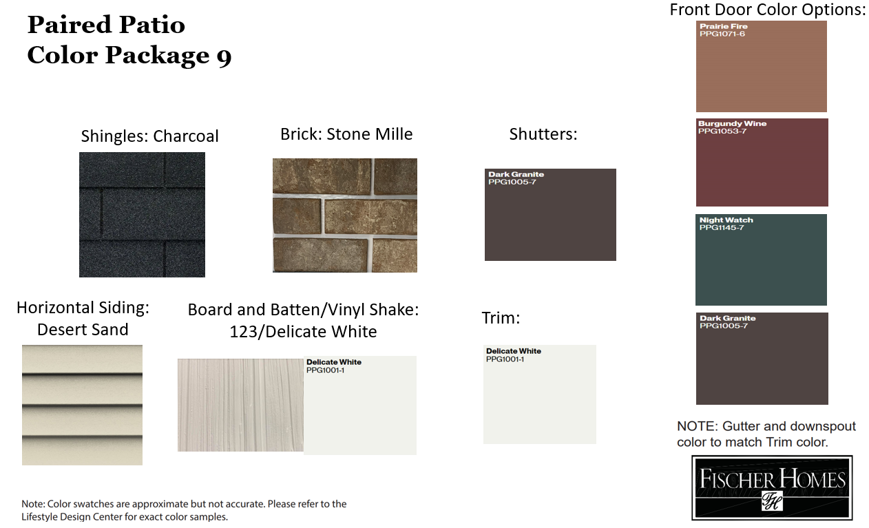

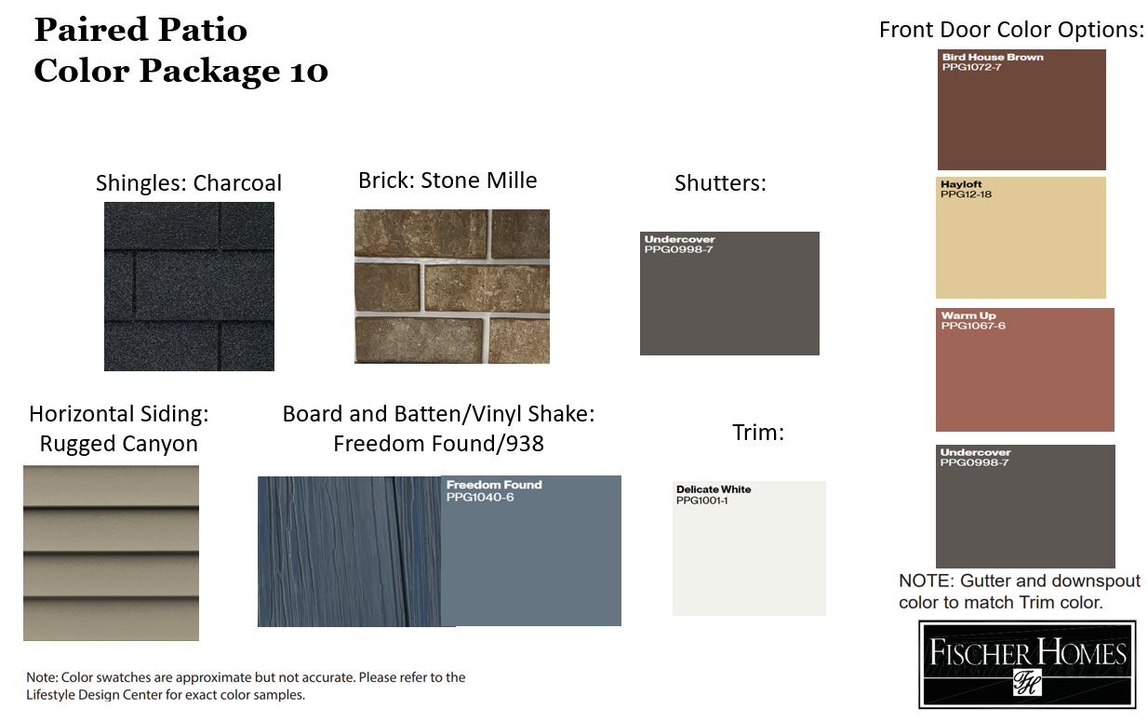

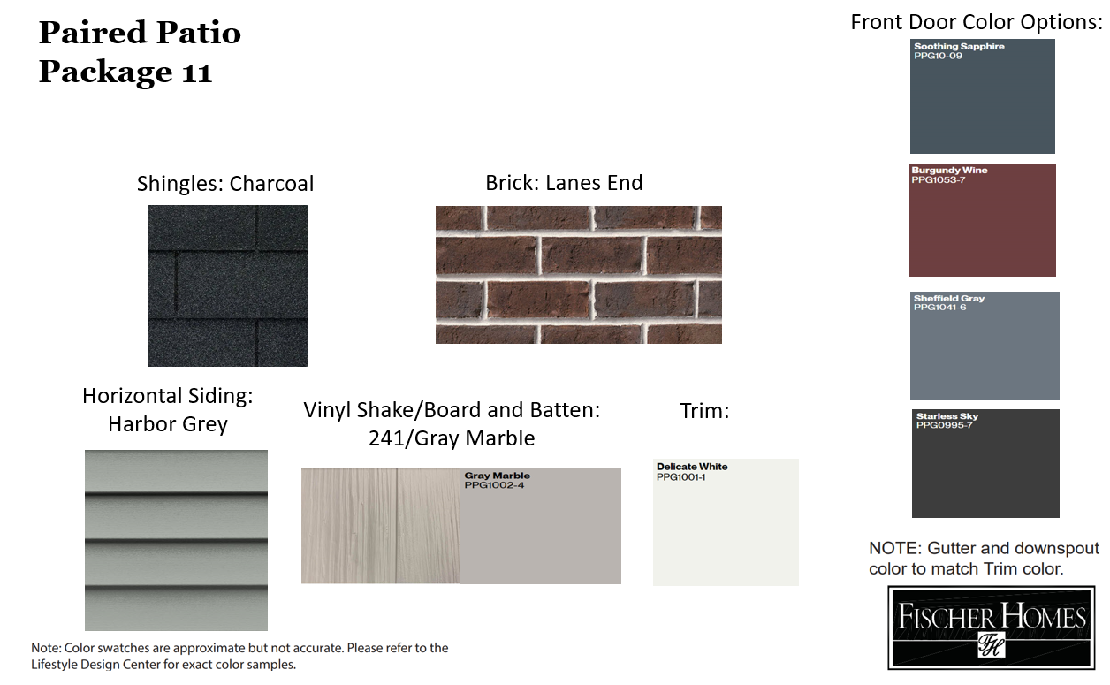

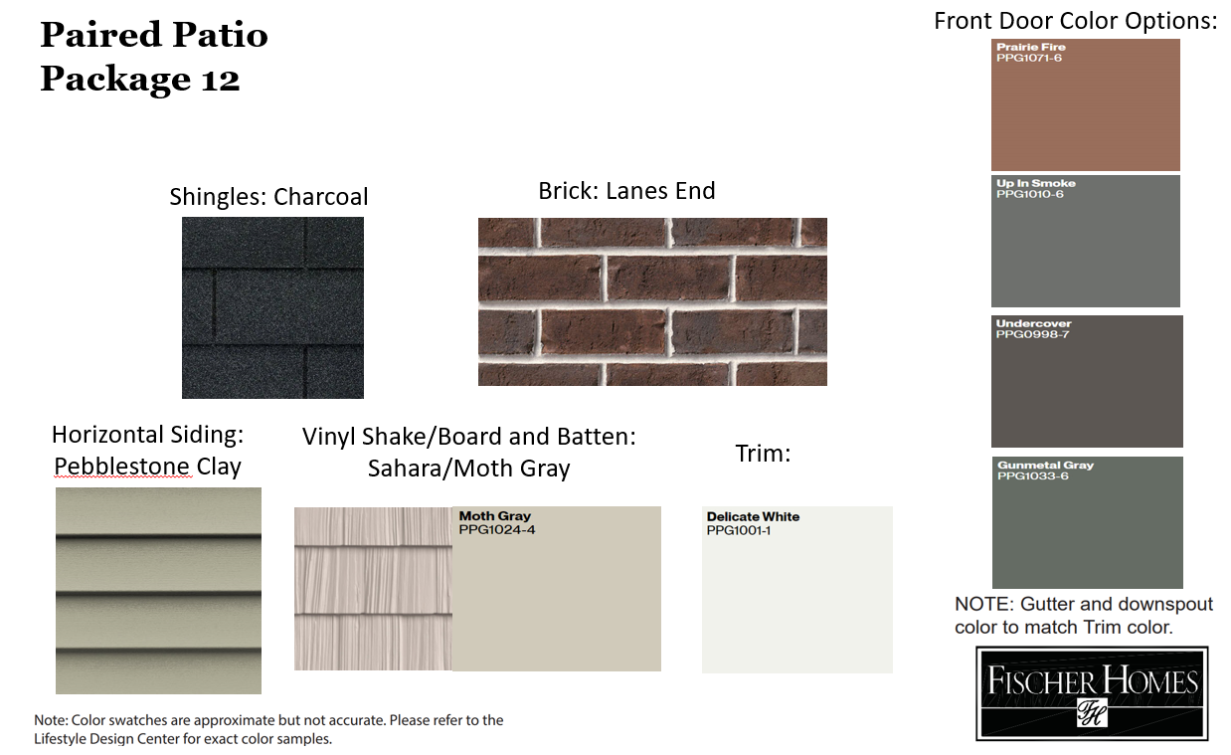

- Final PUD Plan- See page P002 of Plan Set for full-size version.
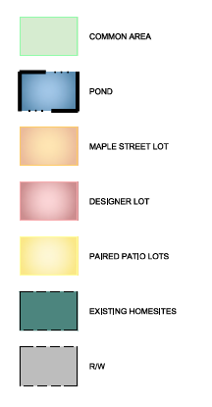
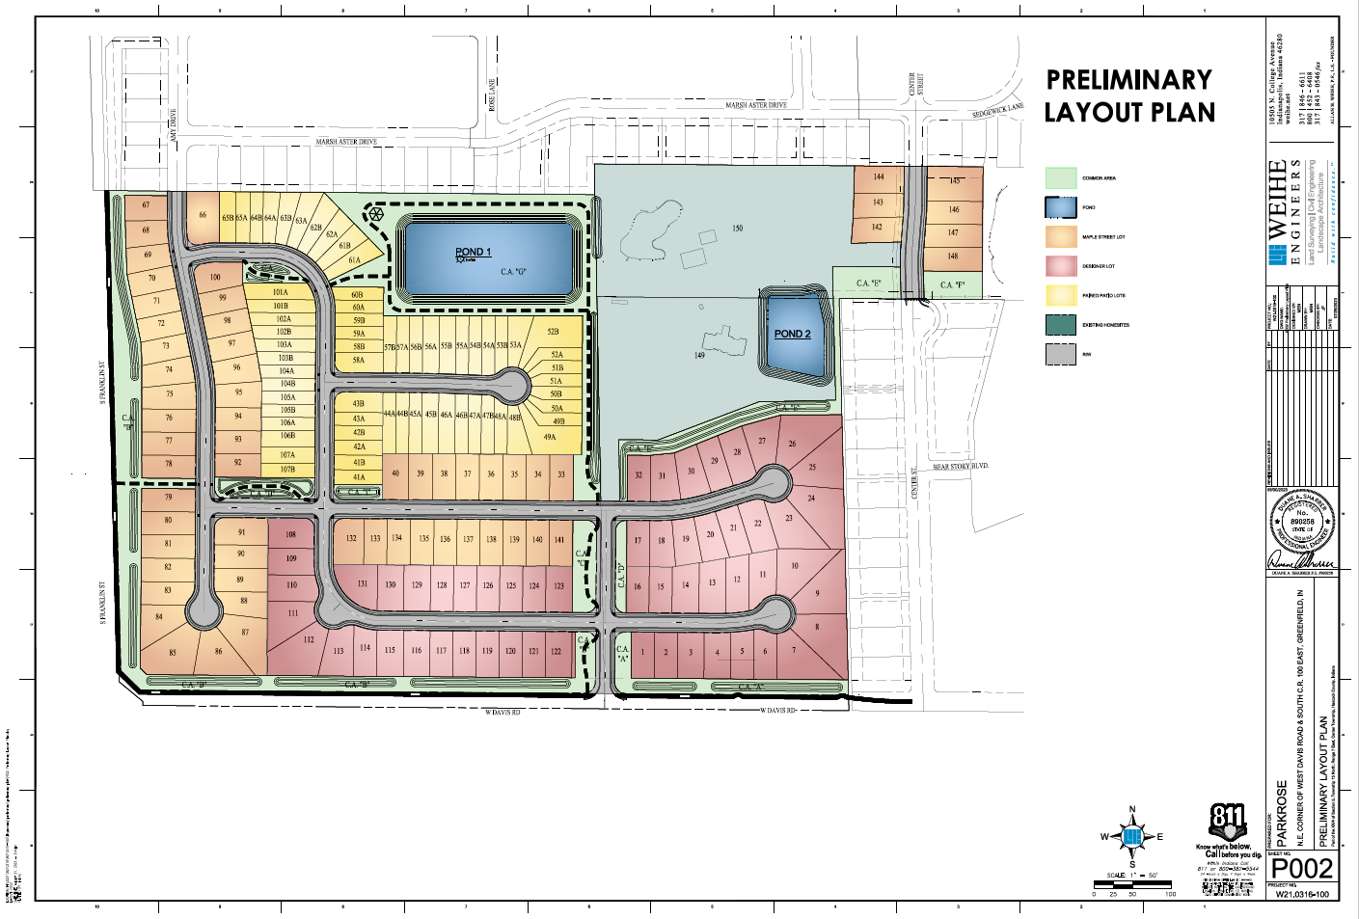
- Phasing Plan - Developer reserves The right to modify phasing plan up to 10% of lots without the plan comission approval. Second access shall be required once the 50th building permit in the development is granted. - See page P112 of Plan Set for full-size version.
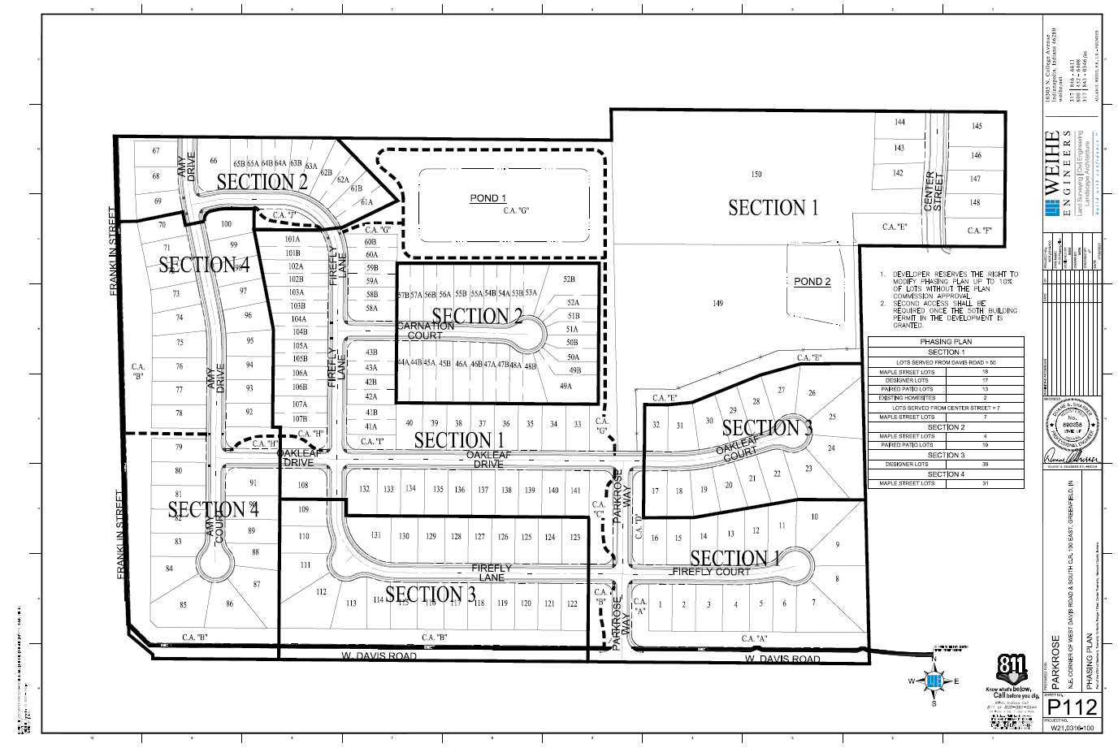
SECTION V. Statement of Commitments:
Open Space, Landscaping, and Screening Commitments
- Open Space
  - The open space shall be in conformance with the Final Development Plan. All common open space shall be owned and maintained by the HOA.
  - Seating pockets shall be constructed near Pond 1, including a bench, trash can, and landscaping.
  - A trellis or gazebo structure shall be constructed near Pond 1.
  - Pond 1 will contain a fountain.
- Landscaping
  - Mounded landscaping will be installed along perimeter streets (Davis Road & Franklin Street).
  - Landscaping shall be provided in accordance with Section 155.063 of the Unified Development Ordinance and Chapter 97 of the Greenfield Code of Ordinances. Landscaping species shall be consistent with Section 155.063 of the Unified Development Ordinance and Chapter 97 of the Greenfield Code of Ordinances, but the right to substitute based on material availability is reserved. A final landscaping plan and any modifications shall be approved by the Planning Director.
  - Landscaping will be installed on both sides of Parkrose Way, and as a buffer to the existing residences. Additionally, landscaping will be installed in Common Area H, Common Area I, and Common Area J.
  - All landscaping shall be consistent with what is shown on the Final Development Plan. Any substitutions due to plant availability must be similar in material and size. All common area landscaping shall be owned and maintained by the HOA.
  - Street trees to be installed in yard (in lieu of tree lawn) to avoid utility conflicts.
  - Effort shall be made to preserve trees east and west of Center Street. Tree preservation efforts shall be coordinated with the Planning Director.
- Fencing
  - A fence is proposed along the property line of the two existing residences and common area at the north part of the property.
- Pedestrian Connections
  - Pedestrian pathways will be constructed along Franklin Street and Davis Road.
  - Pedestrian pathways will be installed within the community as noted on Exhibit A and on the Final PUD plan.
  - Pedestrian pathways not located within the right-of-way will be maintained by the HOA. Pedestrian pathways provided in Common Areas B, C, G, H, and J shall be within a pedestrian transportation easement.
- Center Street Extension
  - Petitioner will do everything within Petitioner’s control to cause the extension of Center Street between the existing northern and southern segments, including assisting with vacation of right-of-way and removal of the existing cul-de-sac ball.
- Paired Units
  - A minimum of 25% of buildings shall have courtyard driveways.
  - Lots 41, 45, 47, 50 or 51, 54, 57, 59, 61, 64, 103, 105, 107 shall be designated as courtyard driveway buildings. Developer/Builder reserves the right to adjust these lot designations but will maintain a minimum of 25% of buildings with courtyard drives with the intent of breaking up facades along the streetscape.

SECTION VI. ORDER AND ESTIMATED TIME OF DEVELOPMENT
Parkrose is planned to begin construction in late Spring 2024 or Summer 2024 pending final approvals. It is anticipated that Parkrose shall be completed in four (4) phases; however, phasing is subject to change.

SECTION VII.
This Ordinance shall be in full force and effect from and after its passage as provided by law.

Passed in Council this ______ day of _________________, 2023.
__________________________________
Chuck Fewell, Presiding Officer

Voting Affirmative: Voting Opposed:

___________________________________ ____________________________________
Kerry Grass Kerry Grass

___________________________________ ____________________________________
Jeff Lowder Jeff Lowder

___________________________________ ____________________________________
Mitch Pendlum Mitch Pendlum

___________________________________ ____________________________________
George Plisinski George Plisinski

___________________________________ ____________________________________
Dan Riley Dan Riley

___________________________________ ____________________________________
Anthony Scott Anthony Scott

___________________________________ ____________________________________
John Jester John Jester

ATTEST:

____________________________________
Lori Elmore, Clerk-Treasurer

Presented by me to the Mayor this ______ day of ______________________, 2023.

__________________________________
Lori Elmore, Clerk-Treasurer

Approved by me this ______ day of _______________________, 2023.

__________________________________
Chuck Fewell, Mayor
City of Greenfield

